**Modelling the dynamics and phenotypic consequences of tiller outgrowth and cessation in sorghum**

GL Hammer, G McLean, J Kholova, and E van Oosterom

Manuscript for in silico Plants issue ???

***Abstract***

***Introduction***

Tillering in cereals has significant consequences on crop adaptation. It influences the development of canopy leaf area, which dictates crop growth and the dynamics of resource capture through the crop life cycle via the extent and timing of light interception, and demand for water and nutrient use. Hence, high tillering is advantageous to growth and yield in favourable environments as resource capture can be maximised, but the opposite occurs in adverse environments where resources, such as available water can limit growth. In those situations, low tillering, with reduced canopy leaf area, and the associated metering out of available water to the post-anthesis phase of the crop cycle, can enhance crop yield (Hammer et al., 2014; Borrell et al., 2014). This trait-by-environment interaction confounds the role of tillering in cereal adaptation and breeding (Doust, 2007).

Tillers emerge from the outgrowth of axillary buds located in the leaf axil of each main culm phytomer (Schmidt and Theres, 2005), which is the repeated unit of main culm structure consisting of a leaf blade, leaf sheath, stem node, stem internode, and axillary tiller bud. Tillering is a common feature of many key cereal crops and varies in magnitude from the high-tillering species wheat, barley, rice, and millet (Kirby et al., 1985; van Oosterom and Acevedo, 1992; Zhong et al., 2002; Bidinger and Raju, 2000) to low-tillering species such as sorghum and maize (Kim et al., 2010; Rotili et al., 2021).

The outgrowth of tiller buds is regulated by a range of environmental and genetic factors. Kim et al. (2010a) showed that tiller appearance in sorghum was highly synchronized with main shoot leaf appearance. Further, a generalized index of internal plant competition for assimilate, which took account of plant assimilate supply and demand from the main culm (S/D index) during the critical period for tillering, explained most of the variation in maximum tiller number observed across their experiments for a specific genotype. The S/D index incorporated incident radiation and leaf size to index S during the period of tiller appearance, and potential leaf area growth of the main culm during that period to index D.

Studies on diverse sorghum genotypes demonstrated significant genetic variation in tillering (Alam et al., 2014a; Kim et al., 2010b). They showed that by considering variation in the assimilate S/D index to capture effects of surplus assimilate availability on tillering, the remaining genotypic differences in tillering could be explained by an independent propensity to tiller (PTT). Alam et al. (2014b) identified QTL for tillering from analysis of multiple sorghum populations that were associated with PTT and traits influencing S/D index, such as leaf size and leaf appearance rate. These factors (PTT and S/D index), which are capable of explaining phenotypic responses at plant/crop scale (Alam et al., 2017), represent quantifications of hormonal effects and their interactions with sucrose availability operating at molecular scale (Dun et al., 2009; Mason et al., 2014; Kebrom and Mullet, 2015; Bertheloot et al., 2019). Hence, the effects quantifying variation in tillering observed in sorghum align with the emerging understanding of gene networks and signalling controlling shoot branching (Barbier et al., 2019).

The total number of axillary buds that outgrow to form nascent tillers depends on the extent of inter-plant competition experienced (Lafarge et al., 2002). Lafarge et al. (2002) showed in sorghum that fewer axillary buds grew out to initiate potential tillers in higher density situations, which could be explained by the sensitivity of sorghum to neighbouring plants via variation in light quality. Ballare and Casal (2000) reported reduced branching as a consequence of a decrease in red light to far-red light ratio (R:FR) as would be experienced in situations of increased plant density. The low R:FR generated in these competitive situations is sensed by the phytochrome family of photoreceptors, including the major R:FR sensor phyB (Ballare et al, 1987). Signals perceived by phyB evoke a suite of adaptive responses, including reduced axillary bud growth, such as in clover (Casal et al., 1985) and Arabidopsis (Holalu and Finlayson, 2017).

Not all tillers continue to grow after bud outgrowth, with some ceasing to continue before becoming fertile and ultimately senescing (Lafarge et al., 2002; Larue et al., 2019). In sorghum, it is the ultimate fertile tiller number (FTN) that has greatest impact on canopy leaf area development (Hammer et al., 1993) as the initiated tillers that cease to grow out generally do so at an early stage in their development when their contribution to plant area is minor (Lafarge et al., 2002). In the study on sorghum of Lafarge and Hammer (2002), at the higher density, in addition to fewer tillers initiating there was a more rapid rate of cessation of tiller outgrowth of the tillers that had initiated. This was consistent with findings in a detailed study of the dynamics of tiller production and continued growth in millet (van Oosterom et al., 2001b). These results are consistent with source-sink dynamics and assimilate balance in the plant, which can be related to the extent of internal plant competition via S/D index during tiller expansion, similar to that proposed for rice (Luquet et al., 2006) and as noted for initial tiller outgrowth at an earlier stage of development (Lafarge and Hammer, 2002; Larue et al., 2019).

Attempts to model the dynamics of tiller outgrowth and cessation in sorghum (Lafarge et al., 2002; Lafarge and Hammer, 2002; Larue et al., 2019) have suggested that approaches to quantifying source-sink dynamics and assimilate availability within a hierarchical framework of axes, from main culm to youngest tiller, perhaps offers the best prospects for prediction. This could incorporate environmental drivers and known avenues of genetic variation (Alam et al., 2017). However, the ability to model tillering dynamics realistically across diverse environments and genotypes remains challenging given the difficulties of accurately capturing source-sink dynamics early in crop development. Much emphasis in molecular studies has been put on bud outgrowth and tiller emergence via hormonal drivers and their interactions with sucrose (Barbier et al., 2015; Fichtner et al., 2017), yet much of the variation in FTN at crop scale relates to cessation of initiated tillers.

Here, we hypothesise that differences in tillering are generated by genetic, management, and environmental factors via effects on tiller outgrowth and tiller cessation. In addition to genetically regulated hormonal factors, this likely reflects differences in morphology and their consequences on source-sink dynamics via interactions with environmental conditions that determine assimilate availability surplus to the needs of the main culm and established tillers. The objective of this study is to develop a generic phenomenological model for sorghum that incorporates key genetic and environmental controls to predict dynamics of outgrowth and cessation of tillers throughout the crop life cycle.

***Model Overview***

There are four key phases defining the dynamic of tillering through the life cycle in sorghum (Fig.1) and the model proposed quantifies each. Firstly, the pre-tillering phase occurring immediately after emergence, is the period prior to any bud outgrowth when initial seedling growth and plant establishment is occurring. There are four leaf initials in the seed embryo in sorghum (Paulson, 1969) and the pre-tillering period extends until about the time of full expansion of the fourth leaf when the fifth leaf is expanding (Lafarge and Hammer, 2002). Secondly, tiller bud outgrowth commences at the end of the pre-tillering period with extent depending on both genetic and environmental factors (Kim et al., 2010 a,b; Alam et al., 2014a), which, as noted above, could be quantified by PTT, likely associated with hormonal effects (Dun et al., 2009; Bertheloot et al., 2019), in combination with genetic and environmental effects on source-sink balance and thus sucrose availability (Mason et al., 2014; Barbier et al., 2019) as quantified by the S/D ratio. The size of leaves on the main culm and their rate of appearance both influence the S/D ratio. Thirdly, tiller emergence ceases once sensing of neighbouring plants via variation in light quality dictates (Ballare and Casal, 2000). Lafarge et al. (2002) observed a common leaf area index of 0.65 across a wide range of plant density at the time of tiller emergence cessation in sorghum. This value reflects a situation where the canopy is still quite open and intercepting only approximately 20% of incident radiation (Hammer et al., 2010; George-Jaeggli et al., 2013). At the time of tiller emergence cessation, the total tiller number (TTN) that will occur has been realised. Fourthly, after tiller emergence cessation, some emerged tillers experience cessation of continued growth so that not all progress to reproductive development and flowering to become fertile tillers. It is the ultimate fertile tiller number (FTN) that has greatest impact on canopy leaf area development and hence, crop growth and yield (Hammer et al., 1993). The balance between capacity of an individual plant to maintain supply of assimilate to the increasing demand from leaf growth across the expanding leaves on the main culm and growing tillers provides an avenue to quantify the rate of tiller growth cessation (Lafarge and Hammer, 2002) using a source-sink S/D ratio context.

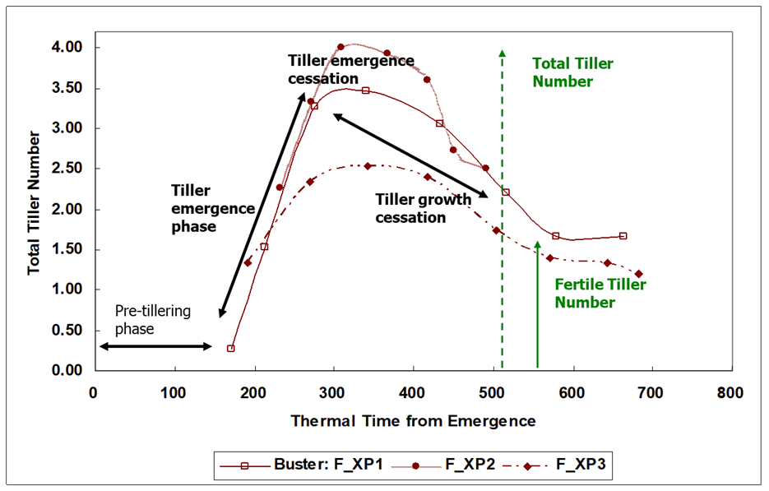

Figure 1. Schematic showing phases defining the dynamics of tillering through the life cycle of sorghum. Total tiller number is the number of tillers initiated by outgrowth of tiller buds, whereas fertile tiller number is the subset that continue to grow and develop, to ultimately flower and set grain. (make a schematic of this fig)

***Leaf size distribution on main stem and tillers***

To quantify plant leaf area, its potential increase, and the source-sink assimilate S/D ratio needed to model tillering dynamics, it is necessary to quantify the size (area) of individual leaves on the main stem and each tiller. Carberry et al. (1993) presented a robust empirical approach to model plant leaf area in tillering sorghum based on the leaf size distribution profile of individual leaves on each culm and their rate of appearance. The leaf size profile was estimated using a relationship between leaf number on an axis (numbered from the base) and the fully expanded leaf area of individual leaves using the equation (Dwyer and Stewart, 1986) –

Y = Yoexp[a(X-Xo)2 + b(X-Xo)3] [1]

where Y is the mature leaf area of an individual leaf, X is the leaf number, Yo is the mature leaf area of the largest leaf, Xo is the leaf number of the largest leaf, and a and b are empirical constants controlling the breadth and skewness, respectively, of the resultant bell-shaped leaf size profile curve. More negative values for ‘a’ result in a sharper peak of the profile. Negative values for ‘b’ result in the profile being skewed towards earlier leaves and positive values result in the profile being skewed towards later leaves.

The parameters Xo, Yo, a, and b have each been generalised via associations with TLN in sorghum (Carberry et al., 1993), maize (Keating and Wafula, 1992; Birch et al., 1998), and pearl millet (van Oosterom et al., 2001a). Although parameter values differed across these crops, in their comprehensive analysis van Oosterom et al. (2001a) observed that estimates for Xo, a, and b based on associations with TLN were similar, suggesting that species differences in leaf area profiles were predominantly associated with differences in Yo. Hence, the general associations of Xo, a, and b with TLN as reported by van Oosterom et al (2001a) were used here -

Xo = 3.58 + 0.60* TLN [2]

a = 0.00955 + (0.0608/(1 – 0.1293*TLN)) [3]

b = 0.00144 + (0.0025/(1 – 0.1100*TLN)) [4]

Leaf size profile data for the elite sorghum hybrid ‘Buster’ that covered a range in TLN from 12 to 18 was collated from field and lysimetry experiments (Lafarge et al. 2002; van Oosterom et al., 2021). There was a linear association of Y0 with TLN over this range (Fig. 2), such that –

Yo = -137.4 + 42.1* TLN [5]

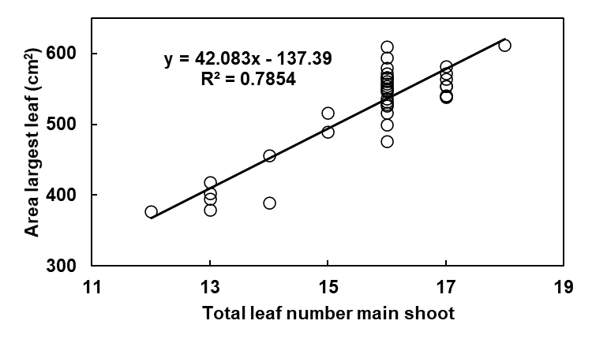

Figure 2. Association between the area of the largest leaf on the main culm (Yo, cm2) and total leaf number (TLN) on that culm for the elite sorghum hybrid ‘Buster’.

The leaf size profile equations ([1] – [5]) were fitted to the individual leaf size profile data on sorghum from the detailed study on tillering of Lafarge et al. (2002). There was a good fit for the leaf size profile on the main culm and for the tillers (Fig. 3) once adjustments were made for TLN and size of the largest leaf on each tiller. It was necessary to ????? reduce max leaf size by x% for each tiller ? Yo - T3 – 83%; T4 – 79%; T5 – 71%???? to estimate Yo for each axis based on that for the main culm. Comment on adequacy of fit of generic coefficients? (curvature)? Limited applicability TLN range.

INSERT FIGURE 3 HERE

Figure 3. Average individual leaf area versus leaf position for leaves on the main shoot (□), tiller 2 (O), tiller 3 ( ), and tiller 4 ( ) for 16-leaf plants of the sorghum hybrid ‘Buster’ in the low density treatments of the experiments of Lafarge et al. (2002). Bars are standard errors of measurements and solid lines indicate fit of leaf size profile equations.

* Association of tiller parameters to main culm ???? (EvO doc) (Hopefully not needed )
  + Leaf number difference MS🡪 tiller TLN reduction
  + Further, results for sorghum and pearl millet indicated that parameter values differed between main shoots and tillers (Carberry et al., 1993; van Oosterom et al., 2001a), but the possibility to derive tiller parameters form those of the main shoot has not been explored. (???? Use of this). Little effect if ignore this axis effect (van O paper)

Adequacy of leaf size profile approach for predicting LAI for Buster ??? pred-obs validation figure/statement – do we need this????

***Modelling the phases of tillering dynamics***

To predict the ultimate fertile tiller number (FTN) per plant it is necessary to model passage through the four key phases defining the dynamic of tillering through the sorghum life cycle (Fig.1) -

*Pre-tillering and tiller emergence phases*

Over a range of experiments (Lafarge and Hammer, 2002; Kim et al., 2010a) for the elite sorghum hybrid ‘Buster’, no tillers emerged prior to about the full expansion of leaf four. The first tillers (if they occurred) emerged at around full expansion of leaf five and originated from the axillary buds of leaf two (so denoted T2) and leaf one (T1). If both T1 and T2 appeared they were simultaneous (Lafarge et al., 2002). Emergence of any subsequent tillers was synchronised with leaf appearance, with one newly emerged tiller for each additional fully expanded leaf, so that, for example T3 emerged at full expansion of leaf six. Tillers produced the same number of leaves as the main culm less the leaf number from which they emerged. Hence, if the main culm produced 16 leaves, T3, which emerged from the axillary bud of leaf three at full expansion of leaf six, would produce 13 leaves, and so on. Given that tillers emerged with their first fully expanded leaf, each tiller reached full expansion of it’s flag leaf two phyllochrons after the main culm.

The total number of tillers that would emerge (TTN) was calculated at the time of full expansion of leaf five based on the propensity to tiller (PTT) and the S/D ratio, as found in the comprehensive study on tillering in sorghum across numerous genotypes and environments by Alam et al. (2014a) -

TTN = PTT + C*S/D [6]

where PTT is the intercept of the relationship between TTN and S/D and C is the slope

* + data from Alam (sorghum);
  + equation details and fitted coefficients (C and D)

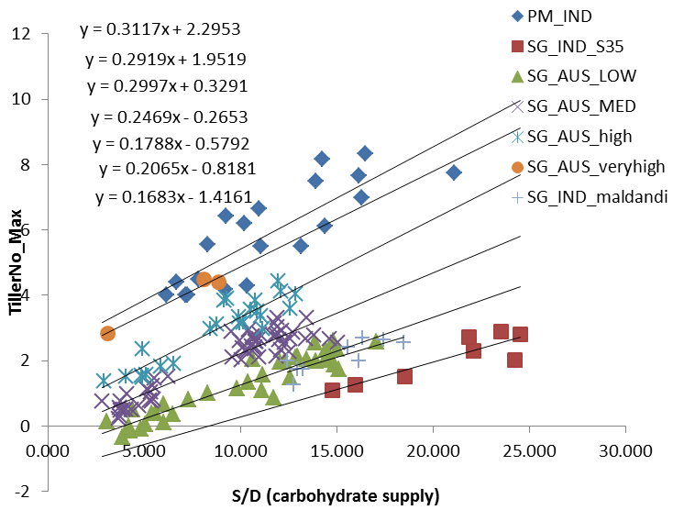

Cessation of tiller emergence

* + data from Lafarge (sorghum)

Tiller growth cessation

* + SLA parameters – surrogate for plant sugar status/signalling
  + parameterisation for sorghum (SLA and tiller no fig for one treatment to explain SLA – 30% idea)
* determinants of FTN (Fig. 1) – brief overview
  + tiller emergence (bud outgrowth) (potential total tiller no)
    - PTT and internal plant competition
  + cessation of tiller emergence (actual total tiller no)
    - limited by canopy size (R/FR signal – Casal)
  + tiller growth cessation (fertile tiller no)
    - assimilation demand/supply balance
    - sugar status indicator (SLA)

***Model Testing***

* experiments
  + use published experiments
  + Lafarge LE20 (? Broad HI expts) for sorghum
* validation simulations
  + model fits – dynamics of tiller no thru crop life cycle (figs)
* plausibility testing
  + G*E*M effects e.g sorghum rule of thumb figs;
  + leaf size effect – narrow, normal, wide leaf sorghum – link to millet and maize and staygreen etc

***Discussion***

* model architecture potential quantitative link to mechanisms and genetics (PTT, S/D ratio, leaf width, hormones, sugar signals) 🡪 phenotypic dissection and dynamics to give emergent props as guidance to molecular discovery (model as integrative repository; testable hypotheses about mechanisms)
  + comment on potential role of stem elongation in the S/D part (still missing in this model).
* comprehensive simulation of QTL (gene network)*M*E possible; adaptation landscape
* generality of framework could work across cereals;
  + link this to results of plausibility testing for leaf size effects and maybe (and discuss millet and maize extrapolations of the G effects within sorghum).
* common gene networks ?(CoE link) – link to CGM-WGP

***References***

Alam, M.M., Hammer, G.L., van Oosterom, E.J., Cruickshank, A., Hunt, C. and Jordan, D.R. (2014a) A physiological framework to explain genetic and environmental regulation of tillering in sorghum. New Phytologist 203: 155-167. <https://doi.org/10.1111/nph.12767>

Alam, M.M., Mace, E.S., van Oosterom, E.J., Cruickshank, A., Hunt, C.H., Hammer, G.L. and Jordan, D.R. (2014b). QTL analysis in multiple sorghum populations facilitates the dissection of the genetic and physiological control of tillering. Theoretical and Applied Genetics 127: 2253-2266.

Alam, M.M., van Oosterom, E.J., Cruickshank, A., Jordan, D.R. and Hammer, G.L. (2017) Predicting tillering of diverse sorghum germplasm across environments. Crop Science 57: 78-87

Ballare, C.L. and Casal, J.J. (2000) light signals perceived by crop and weed plants. Field Crops Research 67:149-160

Ballare, C.L., Sanchez, R.A., Scopel, A.L.,Casal, J.J. and Ghersa, C.M. (1987) Early detection of neighbour plants by phytochrome perception of spectral changes in reflected light. Plant, Cell and Environment 10: 551-557

Barbier, F.F., Dun, E.A., Kerr, S.C., Chabikwa, T.G. and Beveridge, C.A. (2019) An Update on the Signals Controlling Shoot Branching. Trends in Plant Science 24: 220-236

Barbier, F., Péron, T., Lecerf, M., Perez-Garcia, M., Barrière, Q., Rolčík, J., Boutet-Mercey, S., Citerne, S., Lemoine, R., Porcheron, B., Roman, H., Leduc, N., Le Gourrierec, J., Bertheloot, J. and Sakr, S. (2015) Sucrose is an early modulator of the key hormonal mechanisms controlling bud outgrowth in Rosa hybrida. Journal of Experimental Botany 66: 2569–2582. <https://doi.org/10.1093/jxb/erv047>

Bertheloot, J., Barbier, F., Boudon, F., Perez-Garcia, M., Peron, T., Citerne, S., Dun, E., Beveridge, C., Godin, C. and Sakr, S. (2020) Sugar availability suppresses the auxin-induced strigolactone pathway to promote bud outgrowth. New Phytologist 225: 866–879. <https://doi.org/10.1111/nph.16201>

Bidinger, F.R. and Raju, D.S. (2000) Mechanisms of adjustment by different pearl millet plant types to varying plant populations. J. Agric. Sci. Camb. 134:181-189.

Birch, C.J., Hammer, G.L. and Rickert, K.G. (1998) Improved methods for predicting individual leaf area and leaf senescence in maize (Zea mays). Aust. J. Agric. Res. 49: 249-262.

Borrell, A.K., van Oosterom, E.J., Mullet, J.E., George-Jaeggli, B., Jordan, D.R., Klein, P.E. and Hammer, G.L. (2014) Stay-green alleles individually enhance grain yield in sorghum under drought by modifying canopy development and water uptake patterns. New Phytologist 203:817-830. <https://doi.org/10.1111/nph.12869>

Carberry, P.S., Muchow, R.C. and Hammer, G.L. (1993) Modelling genotypic and environmental control of leaf area dynamics in grain sorghum. II. Individual leaf level. Field Crops Res. 33: 311-328.

Casal, J.J., Sanchez, R.A. and Deregibus, V.A. (1985) Variations in tiller dynamics and morphology in *Lolium multiflorum* Lam. vegetative and reproductive plants as affected by differences in red/far-red irradiation. Annals of Botany 56: 553–559.

Doust, A (2007) Architectural evolution and its implications for domestication in grasses. Annals of Botany 100:941-950.

Dun, E.A., Brewer, P.B. and Beveridge, C.A. (2009) Strigolactones: discovery of the elusive shoot branching hormone. Trends Plant Sci. 14, 364–372.

Dwyer, L.M. and Stewart, D.W. (1986) Leaf area development in field-grown maize. Agron. J. 78, 334-343.

Fichtner, F., Barbier, F., Feil, R., Watanabe, M., Annunziata, M.G., Chabikwa, T.G., Hofgen, R., Stitt, M., Beveridge, C.A. and Lunn, J.E. (2017) Trehalose 6-phosphate is involved in triggering axillary bud outgrowth in garden pea (*Pisum sativum* L.). The Plant Journal 92: 611–623.

George-Jaeggli, B., Jordan, D.R., van Oosterom, E.J., Chapman, S., Broad, I.J. and Hammer, G. L. (2013) Sorghum dwarfing genes can affect radiation capture and use efficiency. Field Crops Research, 149: 283-290.

Hammer, G.L., Carberry, P.S. and Muchow, R.C. (1993) Modelling genotypic and environmental control of leaf area dynamics in grain sorghum. I. Whole plant level. Field Crops Res. 33, 293-310.

Hammer, G.L., McLean, G., Chapman, S., Zheng, B., Doherty, A., Harrison, M.T., van Oosterom, E. and Jordan, D (2014) Crop design for specific adaptation in variable dryland production environments. Crop and Pasture Science 65: 614–626.

Hammer, G.L., van Oosterom, E., McLean, G., Chapman, S.C., Broad, I., Harland, P. and Muchow, R.C. (2010). Adapting APSIM to model the physiology and genetics of complex adaptive traits in field crops. Journal of Experimental Botany, 61:2185-2202.

Holalu, S.V. and Finlayson, S.A. (2017) The ratio of red light to far red light alters Arabidopsis axillary bud growth and abscisic acid signalling before stem auxin changes. Journal of Experimental Botany 68: 943–952. <https://doi.org/10.1093/jxb/erw479>

Keating, B.A. and Wafula, B.M. (1992) Modelling the fully expanded area of maize leaves. Field Crops Res. 29: 163-179.

Kebrom, T.H. and Mullet, J.E. (2015) Photosynthetic leaf area modulates tiller bud outgrowth in sorghum. Plant, Cell and Environment 38: 1471–1478.

Kim, H.K., Luquet, D., van Oosterom, E., Dingkuhn, M. and Hammer, G (2010b). Regulation of tillering in sorghum: Genotypic effects. Annals of Botany 106: 69-78.

Kim, H.K., van Oosterom, E., Dingkuhn, M., Luquet, D. and Hammer, G. (2010a). Regulation of tillering in sorghum: Environmental effects. Annals of Botany 106:57-67.

Kirby, E.J.M., Appleyard M. and Fellowes, G. (1985) Leaf emergence and tillering in barley and wheat. Agronomie 5:193-200

Lafarge, T.A. and Hammer, G.L. (2002). Tillering in grain sorghum over a wide range of population densities. Modelling dynamics of tiller fertility. Annals of Botany 90: 99-110.

Lafarge, T.A., Broad, I.J. and Hammer, G.L. (2002). Tillering in grain sorghum over a wide range of population densities. Identification of a common hierarchy for tiller emergence, leaf area development, and fertility. Annals of Botany 90: 87-98.

Larue, F., Fumey, D., Rouan, L., Soulié, J-C., Roques, S., Beurier, G. and Luquet, D. (2019) Modelling tiller growth and mortality as a sink-driven process using *Ecomeristem*: implications for biomass sorghum ideotyping. Annals of Botany 124: 675-690. <https://doi.org/10.1093/aob/mcz038>

Luquet, D., Dingkuhn, M., Kim, H.K., Tambour, L. and Clement-Vidal, A. (2006) EcoMeristem, a model of morphogenesis and competition among sinks in rice. 1. Concept, validation and sensitivity analysis. Functional Plant Biology 33: 309–323.

Mason, M.G., Ross, J.J., Babst, B.A., Wienclaw, B.N. and Beveridge, C.A. (2014) Sugar demand, not auxin, is the initial regulator of apical dominance. Proceedings of the National Academy of Sciences, USA 111: 6092–6097.

Paulson, I.W., 1969. Embryogeny and caryopsis development of Sorghum bicolor (L.) Moench. Crop Science 9, 97–102.

Rotili, D.H., Abeledo, L.G., Devoil, P., Rodriguez, D. and Maddonni, G.A. (2021) Exploring the effect of tillers on the water economy, plant growth and kernel set of low-density maize crops. Agricultural Water Management 243:106424. <https://doi.org/10.1016/j.agwat.2020.106424>

Schmidt, G. and Theres, K (2005) Shoot and inflorescence branching. Current Opinion in Plant Biology 8:506-511.

van Oosterom, E.J. and Acevedo, E. (1992) Adaptation of barley (*Hordeum vulgare* L.) to harsh Mediterranean environments. II. Apical development, leaf, and tiller appearance. Euphytica 62:15-27

van Oosterom, E.J., Carberry, P.S. and O’Leary, G.J. (2001a) Simulating growth, development, and yield of tillering pearl millet. I. Leaf area profiles on main shoots and tillers. Field Crops Research 72: 51-66.

van Oosterom, E.J., Carberry, P.S., Hargreaves, J.N.G. and O’Leary, G.J. (2001b) Simulating growth, development, and yield of tillering pearl millet. II. Simulation of canopy development. Field Crops Research 72: 67-91.

van Oosterom, E.J., Kulathunga, M.R.D.L., Deifel, K.S., McLean, G.B., Barrasso, C., Wu, A., Messina, C. and Hammer, G.L. (2021) Dissecting and modelling the comparative adaptation to water-limitation of sorghum and maize: role of transpiration efficiency, transpiration rate, and height. In Silico Plants 2021, vol 3(1): diaa012; <https://doi.org/10.1093/insilicoplants/diaa012>

Zhong, X., Peng, S., Sheehy, J.E., Vispera, R.M. and Liu, H. (2002) Relationship between tillering and leaf area index: quantifying critical leaf area index for tillering in rice. Journal of Agricultural Science 138:269–279. <https://doi.org/10.1017/S0021859601001903>

Craufurd PQ, Bidinger FR. 1988a. Effect of duration of the vegetative phase on shoot growth, development and yield in pearl millet (Pennisetum americanum (L.) Leeke). J. Exp. Bot. 39: 124-139.

Ravi Kumar, S., Hammer, G.L., Broad, I., Harland, P., and McLean, G. (2009). Modelling environmental effects on phenology and canopy development of diverse sorghum genotypes. Field Crops Research, 111: 157-165.